**4.1 Need of OLAP**

There are many advantages that an organization can gain from using OLAP technology so as to change the way it retrieves the useful information from mountain of data stored in the data warehouse, which are as follows :-

**1.**Data can be viewed from different angles, which gives a broader perspective of a problem unlike other models.

**2.** It has been claimed that for complex queries OLAP cubes can produce an answer in around 0.1% of the time required for the same query on OLTP relational data. The most important mechanism in OLAP which allows it to achieve such performance is the use of *aggregations*.

**3.**Another main benefit of using OLAP technology is that it ensures consistency of information and calculations. No matter how fast data is processes through OLAP servers, the summarised report of relevant information is presented in a consistent presentation, so analysts and executives always gets accurate results for their queries and always knows what to look and where.

**4.**Another benefit of using OLAP technology is that it allows the manager to pull down the data from an OLAP database in broad or specific terms. In other words, reporting can be as simple as comparing a few lines of data in one column of a spreadsheet or as complex as viewing all aspects of mountain of data.

**5.**The information extracted from an OLAP database facilitates all the business needs i.e. planning, budgeting, forecasting, reporting and analysis.

**4.2 OLAP Operations**

**1.  Roll-Up –**It is the first operation used in OLAP technology. This operation is an efficient way to summarize the data storedin the database. It performs aggregation on data cube by dimension reduction. Dimension reduction means one or more dimensions are removed from the cube. It means that through this operation, we can easily convert the detailed data into summarized data.

**2.  Drill Down –** Drill Down operation is the opposite of Roll Up operation. This operation is performed by introducing newdimensions. It navigates from less detailed data to highly detailed data. For ex- taking the above example of sales, suppose the sales data is stored in the database year-wise and the end-user wants the data to be displayed month-wise. So Drill Down operation is performed by introducing more dimensions as sales data is displayed month-wise to the end-user.

**3.   Slice –** Slice is defined as the operation of extracting a rectangular subset by choosing a single value for one of itsdimensions. In other words, it means that the end-user can easily and selectively extract a subset of multi-dimensional array corresponding to a single value of one dimension. For ex –suppose the sales data is stored year wise and city wise in the data warehouse and the end-user wants to know the sales of all the years for the Jaipur city, then he or she can easily use slice operation to extract the sales information of all the years for the Jaipur city.

**4.  Dice –**Dice is defined as the operation of extracting a rectangular subset by choosing specific values on more than onedimension. In other words, it means that the analyst can easily extract the subset of multidimensional array corresponding to specific values from more than one dimension. For ex- from the above example the analyst can easily extract the sales information for the year 2003 for the Jaipur city by performing the dice operation on the sales information stored in the data warehouse.

**5. Pivot –**Pivot is an operation that allows the analysts to rotate the cube in different directions so as to view the data indifferent directions. For ex –the analysts can vertically arrange the sales data and horizontally arranges the time period(in years) data, while viewing the data for the sales in a particular city.

**5. Practical Implementation of OLAP operations**

The table which has been discussed below is created in SQL*Plus and used for the practical implementation of OLAP operation is as follows :-

***a. Data of the Table:***

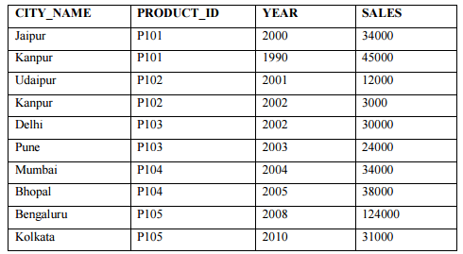

***b.  Roll-Up:***

**1. Query:** Select sum (sales) ―Total Sales‖ ,product_id from cities group by product_id;

**2. Output:**

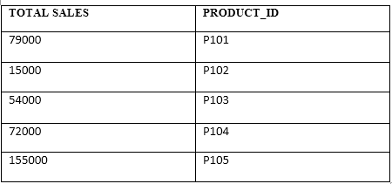

**3. Explanation –** In the above query, we have used **Roll Up** operation to show the summarized total sales of differentproducts according to different cities grouped by their **PRODUCT_ID.**

***c.  Drill-Down :***

**1. Query:** Select city_name, product_id , sales from cities;

**2. Output:**

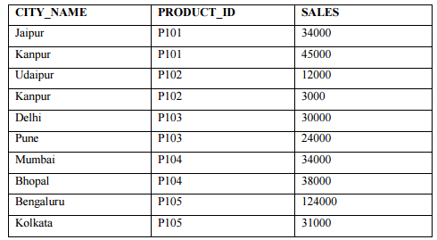

**3. Explanation –** In the above query, we have used **Drill Down** operation to show the detailed information about the sales of different products in different cities.

***d.  Slice:***

**1.** **Query: S**elect * from cities where product_id='P101';

**2.** **Output:**

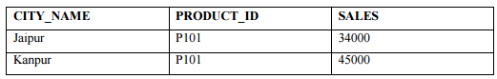

**3.** **Explanation –** In the above query, we have used **Slice** operation to show the detailed information about the sales of product id **P101** in Jaipur and Kanpur.

***e.*** ***Dice:***

**1.** **Query: S**elect * from cities where product_id='P101' and city_name=’Kanpur’;

**2.** **Output:**

https://media.licdn.com/mpr/mpr/AAEAAQAAAAAAAAgQAAAAJGM4Y2U4ODI2LWMzN2YtNDdkMC04ZTU2LTEwOTI0MmRiZWNiNw.png

**3.** **Explanation –** In the above query, we have used **Dice** operation to show the detailed information about the sales of product id **P101** in only Kanpur.

***f.*** ***Pivot:***

**1. Query: S**elect year, city_name, product_id, sales from cities;

**2. Output:**

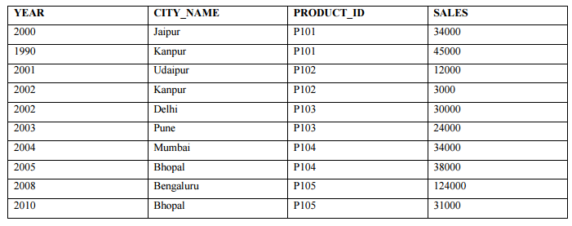

**3. Explanation –** In the above query, we have used **Pivot** operation to change the visual representation of the detailedinformation about the sales of different products in different cities.

**6. Conclusion**

Data mining and its techniques simplifies how to extract knowledge or information from data storage(data warehouse).Data mining is applied effectively not only in business environment but also in other fields such as weather forecast, medicine, transportation, healthcare, insurance, government etc. The OLAP technology provides better performance for accessing multidimensional data. OLAP is a technology that can be distributed to many users on a variety of platforms. It provides the foundation for analytical processing through flexible information access. There are many on-going researches on Data mining and OLAP. Our purpose of this research is to give easy and understandable concepts about data mining and OLAP. Along with these we have also discussed the practical implementation of OLAP operations.